Where are we?

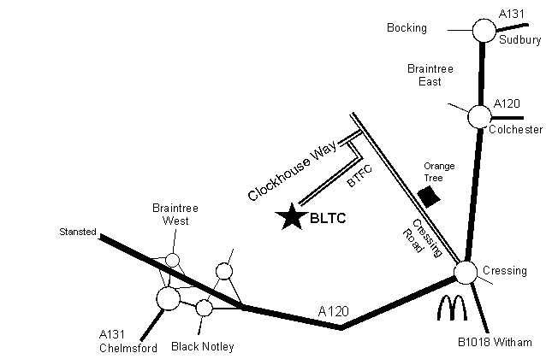

DIRECTIONS

Leave the A120 Braintree bypass at the McDonald's roundabout and head towards the town centre along Cressing Road. Pass the Orange Tree Pub on the right and turn left opposite the bus shelter into Clockhouse Way. 20 yards turn left again into Braintree Town Football Club. Bear right and follow the track through the gate to the clubhouse.

For more information: Membership Sue Spinks 07803 256856

E-mail bltcsec@aol.com

Coaching Rob Hardy 07710 420226

E-mail robhardyptc@gmail.com




www.braintreeltc.co.uk


Braintree Tennis Club

Special Family Membership
for You and Your family



Come and Visit.
Keep Fit. Have Fun.
Play Tennis.



Introduction
Braintree Tennis Club was formed in 1983 and is situated in a secluded, but spacious location near to Braintree Town Football Club. The Club has three floodlit artificial grass courts for all year round use and one hardcourt that is used throughout the day and lighter evenings.

The aim of the Club is to promote interest in the sport of tennis for all ages through social play, coaching and competition, and be a family friendly safe place. Braintree Tennis Club is renowned for its friendly atmosphere in all aspects of club life and hospitality towards visitors. It welcomes friends, visiting players and new members and hopes that all will enjoy the club.

Tennis is a great activity to get the whole family together and active, all year round. Sign up to our special family tennis membership that allows families to be together on court

Monday – Friday 3pm – 6pm (*Restrictions apply)
Sundays up to 2pm

*Coaching and Matches take priority, normally we have enough court space to accommodate all activities.
*This Special Family Membership does not give full membership rights, for more details of add on membership benefits please see our main club leaflet or speak with a committee member.

2 adults + up to 4 children at the same address

Annual Membership for £50 per year*

Tennis is good for you and your family!
Tennis is a lifelong sport, providing physical, psychological and social benefits to all those who play.
The health benefits of playing tennis are often lost when compared to more traditional physical activities like running, swimming and cycling. However, you may not realise that playing tennis for one hour burns about 600 calories, making it as effective as jogging or an indoor cycling class and the beauty of tennis is that it challenges your mind and your body.
The tactical aspect of the game keeps your mind occupied while your body gets a good workout – the short-term goals of reaching that little yellow ball in time makes it a complex sport full of small rewards and limitless challenges.
Studies show how tennis can help improve your mental awareness, your assertiveness, lower your levels of depression, help you portray a positive image and develop self-control. This membership allows your whole family to benefit from being together and building fun into the day.
Family Moments Together make a Memory Last a Lifetime
Special Family Membership Form

Parent/Guardian Name
Parent/Guardian Name
Child Name 1 | Date of Birth:
Child Name 2 | Date of Birth:
Child Name 3 | Date of Birth:
Child Name 4 | Date of Birth:
Phone Number
Mobile Number
E-mail Address
Postal Address
Fees Enclosed | £50
Date
Signed


Send Completed Membership Forms To:

Sue Spinks
3 Harold Rd
Braintree
Essex
CM7 2RU

Tel: 07803 256856
Email: bltcsec@aol.com
Please pay online to:

BLTC
Barclays
Sort Code: 209740
Account Number: 60118249.

Joining mid-season will result in fees being reduced on a pro rata basis.



